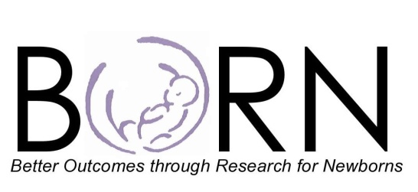

The BORN Network mission is to improve the health of newborns and their families by establishing an evidence base for optimal outcomes. The BORN Network is a national collaborative of pediatric clinicians and researchers focused on evidence-based evaluation of clinical care in the birth setting and transition to home.

Any epidemiologic, health services research, clinical, or translational research proposal may be submitted for consideration. This outline below need not be followed rigidly, but should serve as a template to help structure proposals in a standardized fashion. Initial proposals should be no more than 2-3 pages long. Institutional IRB approval need not be obtained prior to submission of proposals.

All submitted proposals will be reviewed by the BORN Steering committee. After review, principal investigators will be contacted to discuss the committee’s recommendation and for further information as needed. BORN committee members will work with investigators to refine projects, and projects given the highest priority ratings will be approved. Note that studies with a plan for seeking funding will receive priority. Once the network approves a study, we expect that it will be carried out and result in publication. Interested BORN members will be invited to participate in the study. BORN network studies may be network-wide or limited to select sites, depending on the nature of the project, and the discretion of the BORN steering committee, each site’s members, and the principal investigator.

Principal investigators will be primarily responsible for the conception, design, analysis, and authorship of all studies conducted through the BORN network. Likewise, responsibility for acquisition of any needed funds will rest primarily with the principal investigator. BORN in turn will provide a national clinical network through which investigators may conduct research. BORN will hold in confidence submitted research proposals. Submitted projects will only be performed by the network, or if not appropriate for network research, in collaboration with the author.

BORN members will serve as primary data collectors at their home site, and for most studies, BORN members will have the opportunity to participate in regular meetings on the progress and conduct of any studies in which they are involved. BORN members may also serve critical roles in study revision, data acquisition, analysis, and co-authorship in a manner agreed upon by BORN and the principal investigator at the time of study approval. BORN co-investigators who take a leading role in the design and analysis of studies and the revision of manuscripts will be invited to be co-authors on manuscripts resulting from the work.

Thank you for your interest in performing research with BORN! We look forward to working together.

1. Study Title

2. Principal Investigator

3. E-mail and phone number:

4. Co-Investigators (list any)

5. Institution(s)

6. Has IRB approval been obtained at PI’s institution (not needed for submission)?

7. Background/relevance to BORN’s mission (prior studies, justification for multi-center study)

8. Specific Aims

9. Design (e.g., prospective/retrospective cohort; RCT; case control)

10. Subjects (define population, inclusion and exclusion criteria)

11. Outcome measures (primary and secondary)

12. Variables (demographic, clinical and other co-variables to be collected)

13. Data collection procedures (who will collect, sampling strategy as needed, description of data collection instruments)

14. Analysis plan

15. Power calculation (justification of sample size proposed)

16. Funding obtained/planned

17. Additional Comments
18. References

